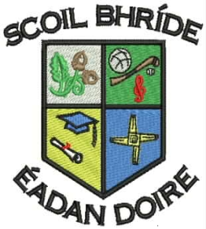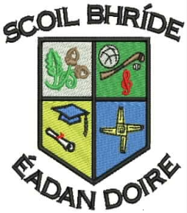

**Scoil Bhríde Primary School**

**Killane, Edenderry, Co. Offaly.**

### Phone / Fax: 046-9773451

### Email: info@scoilbhrideps.com

**Second Class Booklist 2016-2017**

|  |  |  |  |
| --- | --- | --- | --- |
| **Books to be purchased:** | | | |
| **Subject** | **Publisher** | **Name of Book** | **Price** |
| **English** | Educate.ie | Just Handwriting Series - 2nd Class | €4.95 |
|  | Prim-Ed. | Just phonics – 2nd Class | €5.95 |
| **Gaeilge** | C.J. Fallon | Bun go Barr 2 Workbook | €14.60 |
| **Religion** | Veritas | Grow in Love | €8.99 |
| **Total cost of books to be purchased.** |  |  | **€34.49** |

|  |  |  |  |  |
| --- | --- | --- | --- | --- |
| **Book Rental: In an effort to keep costs to a minimum for parents, the school purchases all English, Maths and S.E.S.E. books and rents them to pupils under our book rental scheme.** | | | | |
| **Subject** | **Publisher** | | **Name of Book** | **Price** |
| **English** | Readers | | Various Titles from the following:  PM Readers  Oxford Readers  Accelerated Readers | €15.00 |
| Workbooks | | Exercise Your English Workbook  Treasury B Workbook | €10.00 |
| **Irish** | Readers | | Léigh sa Bhaile B | €3.00 |
| **Maths** | Maths Books | | Various Maths Books | €10.00 |
| **Science** | C.J. Fallon | | Science Quest 2  Small World 2nd Class | €3.00 |
| **Geography** | C.J. Fallon | | Geography Quest 2  Small World 2nd Class | €3.00 |
| **History** | C.J. Fallon | | History Quest 2  Small World 2nd Class | €3.00 |
| **Total Book Rental Fees:** |  | |  | **€47.00** |
| **Photocopying Materials and Testing*:** | | | | |
| **Visual Art, Drama and Music** | | Wide range of materials | | €35.00 |
| **Standardised Tests Materials** | | English and Maths | | €3.00 |
| **Homework Journal** | | Homework Journal | | €2.00 |
| **Total Photocopying Materials and Testing Fees:** | | | | **€40.00** |
| **Total cost to be paid to the school:** | | | | **€87.00** |

**\*Please note the second child and subsequent children in a family can avail of €5 reduction from Photocopying Materials and Testing Fees.**

**Other Items Needed**

* Tin Whistle (Key of D)
* Tables Book (Mathematics)
* Pencil, Eraser, **Red Pen x2,** Pencil Sharpener and Ruler
* A4 Plastic Folder X2 and A3 Zip Plastic Folder X1
* Copy Book X5 (88 pages)
* Sum Copy (C3 7mm/88Page) X4
* Learn to Write B2 Exercise Copy Book (Cursive Writing) X2
* A3 Sketch Pad X1

All of the above books, workbooks and copies must be covered and clearly labelled for the 30th of August. The children will be given their rental books when they start school. Rented books have to be returned at the end of the school year and it is important that they are kept in good condition. When rented books are lost, the book will have to be replaced at their full purchase price.