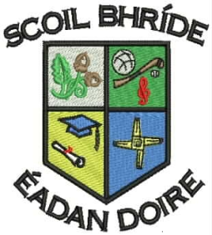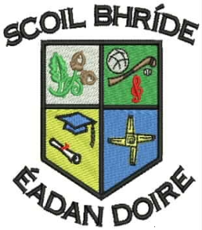

**Scoil Bhríde Primary School**

**Killane, Edenderry, Co. Offaly.**

### Phone / Fax: 046-9773451

### Email: info@scoilbhrideps.com

**Sixth Class Booklist 2016-2017**

|  |  |  |  |
| --- | --- | --- | --- |
| **Books to be purchased:** | | | |
| **Subject** | **Publisher** | **Name of Book** | **Price €** |
| **English** | Educate.ie | Just Handwriting Series - 6th Class | €4.95 |
|  | Prim-Ed. | My Spelling Workbook - Book F | €5.99 |
| **Gaeilge** | C.J. Fallon | Bun go Barr 6 Workbook | €18.05 |
| **Total cost of books to be purchased.** |  |  | **€28.99** |

|  |  |  |  |  |
| --- | --- | --- | --- | --- |
| **Book Rental: In an effort to keep costs to a minimum for parents, the school purchases all English, Maths and S.E.S.E. books and rents them to pupils under our book rental scheme.** | | | | |
| **Subject** | **Publisher** | | **Name of Book** | **Price €** |
| **English** | Readers | | Various Titles from the following:  PM Readers  Oxford Readers  Two Class Novels  Accelerated Readers | €15.00 |
| Workbooks | | Exercise Your English Workbook  Treasury Workbook | €10.00 |
| **Gaeilge** | Reader | | Léigh sa Bhaile F | €3.00 |
| **Maths** | Maths Books | | Various Maths Books | €10.00 |
| **Science** | C.J. Fallon | | Science Quest 6  Small World 6th Class | €3.00 |
| **Geography** | C.J. Fallon | | Geography Quest 6  Small World 6th Class | €3.00 |
| **History** | C.J. Fallon | | History Quest 6  Small World 6th Class | €3.00 |
| **Total Book Rental Fees:** |  | |  | **€47.00** |
| **Photocopying Materials and Testing*:** | | | | |
| **Visual Art, Drama and Music** | | Wide range of materials | | €35 |
| **Standardised Tests Materials** | | English and Maths | | €3 |
| **Homework Journal** | | Homework Journal | | €2 |
| **Total Photocopying Materials and Testing Fees:** | | | | €**40.00** |
| **Total cost to be paid to the school:** | | | | **€87.00** |

**\*Please note the second child and subsequent children in a family can avail of €5 reduction from Photocopying Materials and Testing Fees.**

**Other Items Needed**

* Tables Book (Mathematics)
* Blue Pen X2, Red Pen X2, Pencil, Eraser, Pencil Sharpener, and Ruler
* A4 Plastic Folder X2 and A3 Zipped Plastic Folder X1
* A4 Hardback Copies X2
* Copy Book (88 pages) X5
* Sum Copy (C37mm/88Page) X4
* Mathematical set
* English Dictionary and Irish Dictionary

All of the above books, workbooks and copies must be covered and clearly labelled for the 30th of August. The children will be given their rental books when they start school. Rented books have to be returned at the end of the school year and it is important that they are kept in good condition. When rented books are lost, the book will have to be replaced at their full purchase price.