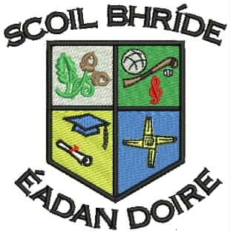
Scoil Bhríde Primary School
Killane, Edenderry, Co. Offaly.

Phone / Fax: 046-9773451

Website: www.scoilbhrideps.com email: info@scoilbhrideps.com

List of School Closures & Events 2016 / 2017

August  - 30th - Re-opening of School | September  - 26th – School Photographer  - 27th – Staff Meeting (School closing at 1.30 pm)
October  - 28th – Halloween Fancy Dress  - 31st Oct. – 04 Nov. (Incl.) – Halloween Mid-Term Break | November
December  - 22nd – Christmas Holidays (school closing at 11.30 am) | January  - 9th – Re-opening of school  - 24th - Staff Meeting (School closing at 1.30 pm)  - 30th & 31st - Parent / Teacher Meetings
February  - 23rd & 24th - Spring Mid-Term Break | March  - 17th – Public Holiday (School Closure)
April  - 7th – Easter Holidays (school closing at 11.30 am)  - 24th – Re-opening of School | May  - 1st – Public Holiday (School Closure)  - 6th – First Holy Communion (12:00pm)  - 9th - Staff Meeting (School closing at 1.30 pm)  - 20th – Confirmation (12:00pm)
June  - 5th - Public Holiday (School Closure)  - 23rd – Summer Holidays (school closing at 11.30 am) | July  - 26th June to 21st July ‘July Provision for pupils with ASDs’ - pending approval of Board of Management & Department of Education & Skills

- In the event that Scoil Bhríde PS has an unplanned closure(s) due to adverse weather conditions, the school may compensate for up to 3 days closure during the first three days of the Easter Holidays, i.e. the school will remain open on either or all of the 10th April / 11th April / 12th of April 2017.

- Relevant parents will be notified of Individual Education Plan (IEP) meeting times by class teachers / resource teachers.

- In consultation with the Chairperson of the Board of Management, the Principal reserves the right to make any future amendments to this list of closures and events.

- The school calendar is also available on our school website – www.scoilbhrideps.com

