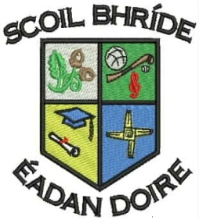
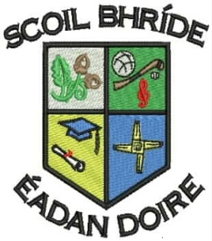
Scoil Bhríde Primary School
Killane, Edenderry, Co. Offaly.

Phone / Fax: 046-9773451

Email: info@scoilbhrideps.com

First Class Booklist 2017-2018
Books to be purchased:
Subject | Publisher | Name of Book | Price
English | Educate.ie | Just Handwriting Series – First Class | €4.95
English | Educate.ie | Just Phonics - First class | €5.95
English | Folens | Jolly Phonics Word Book | €3.30
Gaeilge | Edco | Bua na Cainte 1 | €10.25
Maths | Folens | Planet Maths Workbook – First Class | €13.60
SESE | CJ Fallon | Small World 1st Class | €11.15
Religion | Veritas Publications | Grow in Love – First Class | €8.99
Total cost of books to be purchased. |  |  | €58.19

Book Rental: In an effort to keep costs to a minimum for parents, the school purchases all English, Maths and S.E.S.E. books and rents them to pupils under our book rental scheme.
Subject | Publisher |  | Name of Book | Price
English | Readers |  | Various Titles from the following:  PM Readers  Oxford Readers | €15.00
English | Workbooks |  | Exercise Your English Workbook  Treasury Workbook | €10.00
Gaeilge | Bua na Cainte |  | Resources | €3.00
Total Book Rental Fees: |  |  |  | €28.00
Photocopying Materials and Testing*:
Visual Art, Drama and Music |  | Wide range of materials |  | €35.00
Standardised Tests Materials |  | English and Maths |  | €3.00
Homework Journal |  | Homework Journal |  | €2.00
Total Photocopying Materials and Testing Fees: |  |  |  | €40.00
Total cost to be paid to the school: |  |  |  | €68.00

*Please note the second child and subsequent children in a family can avail of €5 reduction from Photocopying Materials and Testing Fees.
Other Items Needed
- Tin Whistle ( Key of D)
- Tables Book (Mathematics)
- Pencils X2, Pencil Erasers X2, Pencil Sharpener X1
- A4 Plastic Folder X2 and A3 Zipped Folder X1
- Copy Book X4 (88 pages)
- Project copy X4 (Capital No.15 Project book)
- Junior Sum Copy (1cm (10mm) Square / 40 Page) X 2
- Learn to Write B2 Copies (from brands such as Capital, Aisling and Ormond) X2
All of the above books, workbooks and copies must be covered and clearly labelled for the first day of school. The children will be given their rental books when they start school. Rented books have to be returned at the end of the school year and it is important that they are kept in good condition. When rented books are lost, the book will have to be replaced at their full purchase price.

