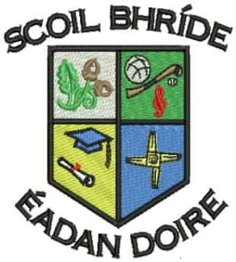
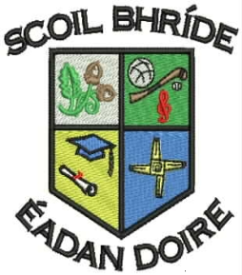
Scoil Bhríde Primary School
Killane, Edenderry, Co. Offaly.

Phone / Fax: 046-9773451

Email: info@scoilbhrideps.com

Third Class Booklist 2017-2018
Books to be purchased:
Subject | Publisher | Name of Book | Price
English | Educate.ie | Just Handwriting Series - 3rd Class | €4.95
 | Prim-Ed | My Spelling Workbook C | €6.99
Gaeilge | C.J. Fallon | Bun go Barr 3 Workbook | €18.15
Total cost of books to be purchased. |  |  | €30.09

Book Rental: In an effort to keep costs to a minimum for parents, the school purchases all English, Maths and S.E.S.E. books and rents them to pupils under our book rental scheme.
Subject | Publisher |  | Name of Book | Price
English | Readers |  | Various Titles from the following:  PM Readers/Oxford Readers  Two Class Novels  Accelerated readers | €15.00
English | Workbooks |  | Exercise Your English Workbook  Treasury Workbook | €10.00
Irish | Reader |  | Léigh sa Bhaile C | €3.00
Maths | Maths Books |  | Various Maths Books | €10.00
Science | C.J. Fallon |  | Science Quest 3  Small World 3rd Class | €3.00
Geography | C.J. Fallon |  | Geography Quest 3  Small World 3rd Class | €3.00
History | C.J. Fallon |  | History Quest 3  Small World 3rd Class | €3.00
Total Book Rental Fees: |  |  |  | €47.00
Photocopying Materials and Testing*:
Visual Art, Drama and Music |  | Wide range of materials |  | €35.00
Standardised Tests Materials |  | English and Maths |  | €3.00
Homework Journal |  | Homework Journal |  | €2.00
Total Photocopying Materials and Testing Fees: |  |  |  | €40.00
Total cost to be paid to the school: |  |  |  | €87.00
*Please note the second child and subsequent children in a family can avail of €5 reduction from Photocopying Materials and Testing Fees
Other Items Needed
- Tin Whistle (Key of D)
- Tables Book (Mathematics)
- Pencil, Eraser, 1 Pencil Sharpener, Red Pen X2 and a Ruler
- A4 Plastic Folder X2 and A3 Zipped Folder X1
- Copy Book (88 pages) X7
- Sum Copy (C3 7mm/88Page) X4
- Learn to Write B2 Exercise Copy Book (Cursive Writing) X1
All of the above books, workbooks and copies must be covered and clearly labelled for the 30th of August. The children will be given their rental books when they start school. Rented books have to be returned at the end of the school year and it is important that they are kept in good condition. When rented books are lost, the book will have to be replaced at their full purchase price.

